GUESS THE PLACES
Can you name the landmarks in England?
Question 1 |  | BUCKINGHAM PALACE

Question 2 |  | STONEHENGE

Question 3 |  | BLACKPOOL TOWER

Question 4 |  | THE ANGEL OF THE NORTH

Question 5 | 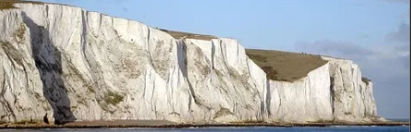 | WHITE CLIFFS OF DOVER

Question 6 | 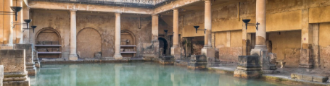 | ROMAN BATHS

Question 7 | 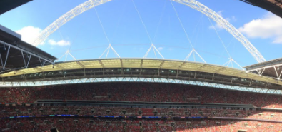 | WEMBLEY STADIUM (SADLY LIVERPOOL DON’T VISIT IT OFTEN)

Question 8 | 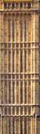 | BIG BEN CLOCK TOWER

Question 9 |  | WILLOW MAN

Question 10 | 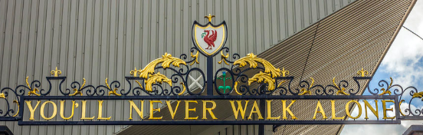 | ANFIELD!!!!

