BUMPER EASTER QUIZ
ROUND ONE – GUESS THE GAME
Question 1 | 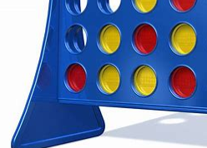 | CONNECT FOUR

Question 2 |  | SCREWBALL SCRAMBLE (CRAZY MAZE)

Question 3 |  | MONOPOLY

Question 4 |  | UNO

Question 5 | 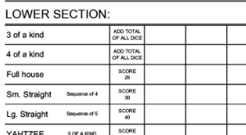 | YAHTZEE

Question 6 |  | CLUEDO

Question 7 |  | BOP IT

Question 8 |  | JENGA

Question 9 |  | PIE FACE

Question 10 |  | KER PLUNK

Question 11 |  | DOBBLE

Question 12 |  | BOGGLE

Question 13 |  | DOMINOS

Question 14 | 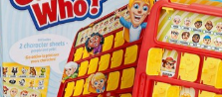 | GUESS WHO

Question 15 | 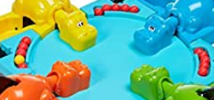 | HUNGRY HIPPOS

Question 16 | 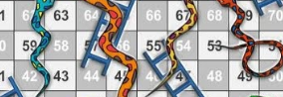 | SNAKES AND LADDERS

Question 17 |  | SCRABBLE

Question 18 |  | PICTIONARY

Question 19 | 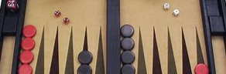 | BACK GAMMON

Question 20 |  | CHESS

ROUND TWO – GUESS THE MUSIC STAR
Question 21 |  | ADELE

Question 22 |  | LOUIS TOMLINSON

Question 23 | 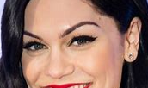 | KATY PERRY

Question 24 |  | ELTON JOHN

Question 25 |  | TAYLOR SWIFT

Question 26 | 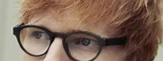 | ED SHEERAN

Question 27 |  | PAUL MCCARTNEY

Question 28 |  | ANNIE LENNOX

Question 29 |  | DIANA ROSS

Question 30 |  | TOM JONES

Question 31 | 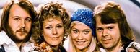 | ABBA

Question 32 | 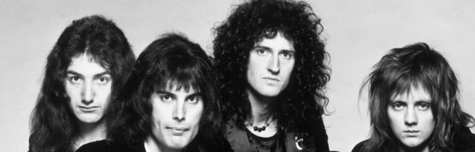 | QUEEN

Question 33 | 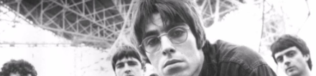 | OASIS

Question 34 |  | ONE DIRECTION

Question 35 |  | LITTLE MIX

Question 36 | 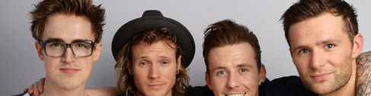 | MCFLY

Question 37 | 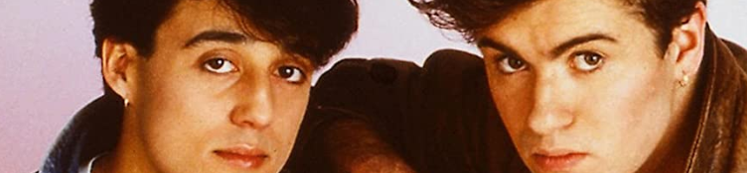 | WHAM

Question 38 | 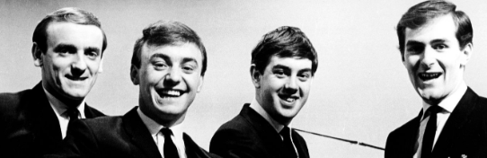 | GERRY AND THE PACEMAKERS (HAD TO BE IN THE QUIZ)

Question 39 | 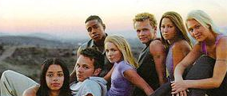 | S CLUB 7

Question 40 |  | BUCKS FIZZ

ROUND THREE – GUESS THE MOVIE

Question 41 |  | FORREST GUMP

Question 42 |  | ET

Question 43 | 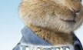 | PETER RABBIT

Question 44 |  | PADDINGTON

Question 45 |  | DUMBO

Question 46 |  | HOME ALONE

Question 47 |  | GREATEST SHOWMAN

Question 48 |  | THE BFG

Question 49 |  | FROZEN

Question 50 |  | MARY POPPINS RETURNS

Question 51 |  | WONDER

Question 52 | 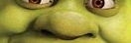 | SHREK

Question 53 |  | TOY STORY

Question 54 | 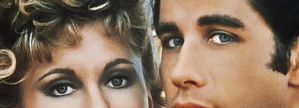 | GREASE

Question 55 |  | HARRY POTTER

Question 56 | 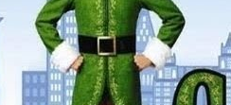 | ELF

Question 57 | 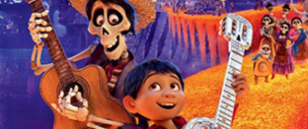 | COCO

Question 58 | 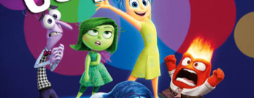 | INSIDE OUT

Question 59 |  | TROLLS

Question 60 | 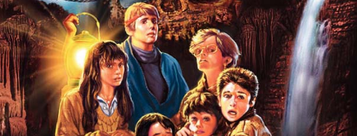 | THE GOONIES

ROUND FOUR – GUESS THE SPORTS STAR

Question 61 | 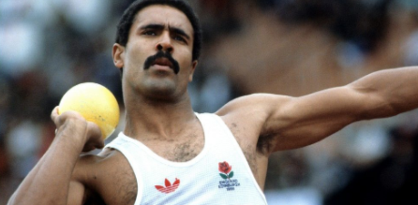 | DALEY THOMPSON

Question 62 | 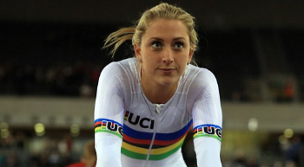 | LAURA KENNY

Question 63 | 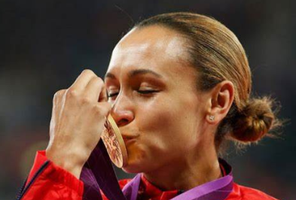 | JESSICA ENNIS

Question 64 | 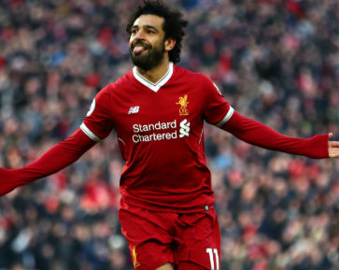 | MO SALAH

Question 65 | 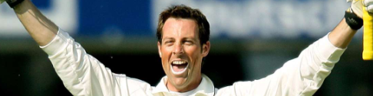 | MARCUS TRESCOTHICK

Question 66 | 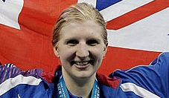 | REBECCA ADLINGTON

Question 67 |  | STEVE REDGRAVE

Question 68 | 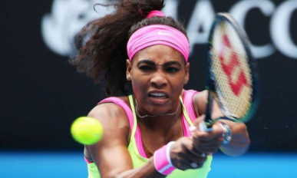 | SERENA WILLIAMS

Question 69 |  | ANDY MURRAY

Question 70 |  | FALLON SHERROCK

Question 71 | 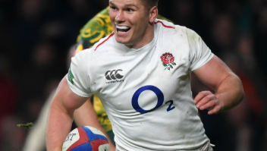 | OWEN FARRELL

Question 72 |  | TIGER WOODS

Question 73 | 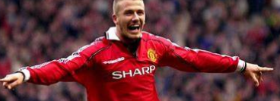 | DAVID BECKHAM

Question 74 | 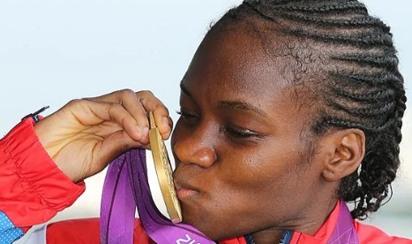 | NICOLA ADAMS

Question 75 | 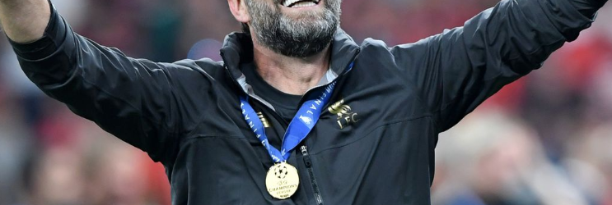 | JURGEN KLOPP

Question 76 | 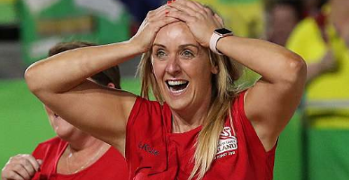 | TRACEY NEVILLE

Question 77 | 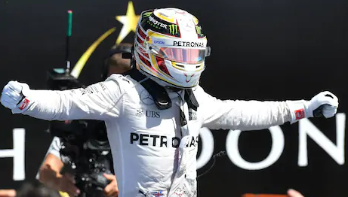 | LEWIS HAMILTON

Question 78 | 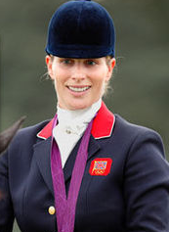 | ZARA TINDALL

Question 79 | 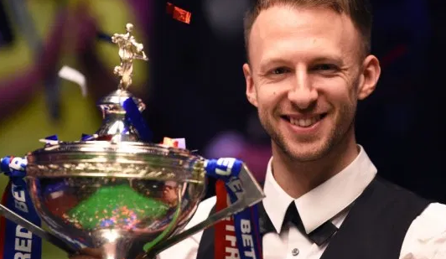 | JUDD TRUMP

Question 80 | 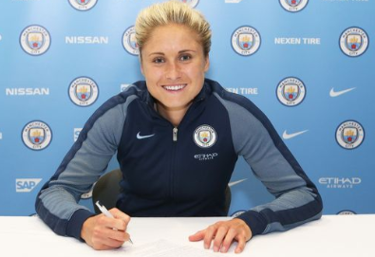 | STEPH HOUGHTON

ROUND FIVE – GUESS THE TV SHOW
Question 81 |  | I’M A CELEBRITY GET ME OUT OF HERE

Question 82 | 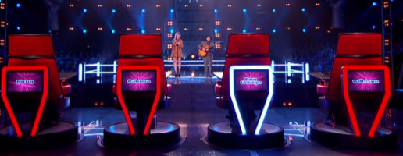 | THE VOICE

Question 83 |  | STRICTLY COME DANCING

Question 84 |  | CAR SHARE

Question 85 |  | BRITAIN’S GOT TALENT

Question 86 | 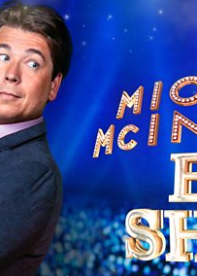 | MICHAEL MCINTYRE’S BIG SHOW

Question 87 | 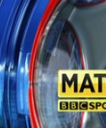 | MATCH OF THE DAY

Question 88 |  | FRIENDS

Question 89 |  | DR WHO

Question 90 |  | SATURDAY NIGHT TAKEAWAY

Question 91 | 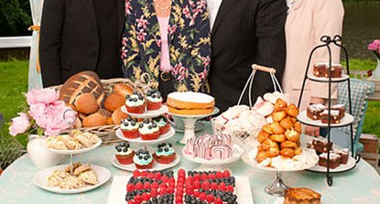 | THE GREAT BRITISH BAKE OFF

Question 92 |  | DOC MARTIN

Question 93 |  | TOP GEAR

Question 94 |  | STILL OPEN ALL HOURS

Question 95 | 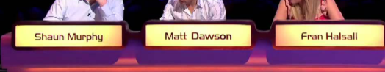 | A QUESTION OF SPORT

Question 96 |  | CALL THE MIDWIFE

Question 97 | 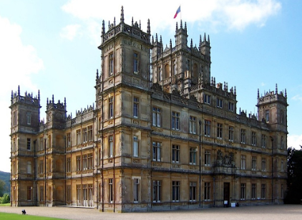 | DOWNTON ABBEY

Question 98 |  | ONLY FOOLS AND HORSES

Question 99 |  | EMMERDALE

Question 100 | 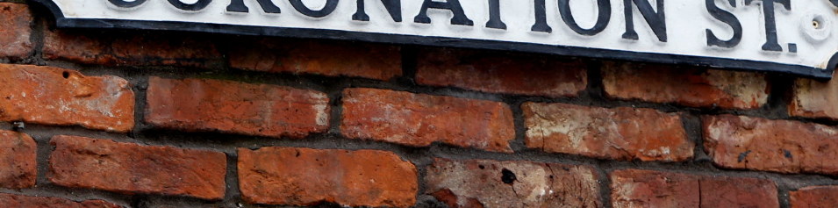 | CORONATION STREET

