GUESS THE PLACES
Can you name the landmarks in England?
Question 1

Question 2 | 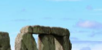

Question 3

Question 4

Question 5 | 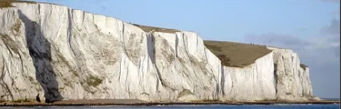

Question 6 | 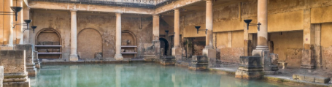

Question 7 | 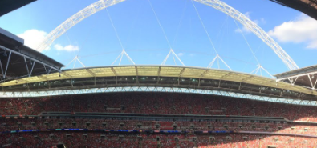

Question 8 | 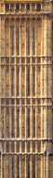

Question 9 | 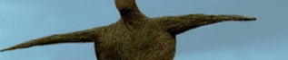

Question 10 | 