GUESS THE BOOK
Question 1 |  | WONDER

Question 2 | 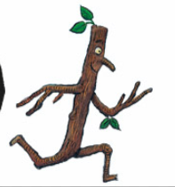 | STICK MAN

Question 3 | 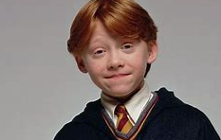 | HARRY POTTER (THIS CHARACTER IS RON WEASLEY)

Question 4 | 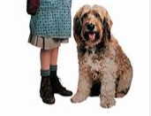 | ANNIE

Question 5 | 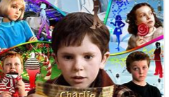 | CHARLIE AND THE CHOCOLATE FACTORY

Question 6 |  | MR STINK

Question 7 | 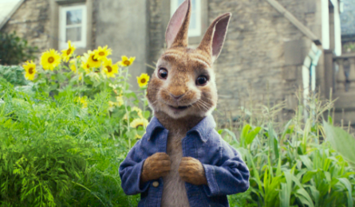 | PETER RABBIT

Question 8 | 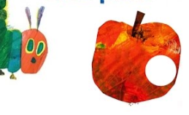 | THE HUNGRY CATERPILLAR

Question 9 | 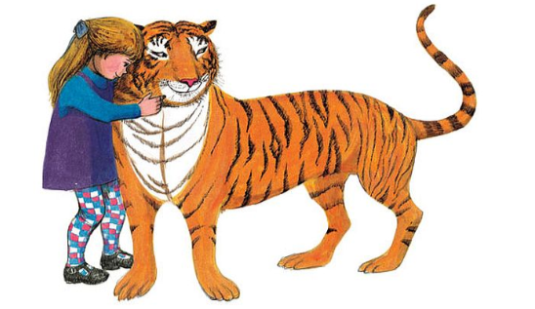 | THE TIGER WHO CAME FOR TEA

Question 10 | 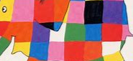 | ELMER

