GUESS THE LANDMARK ANSWERS
Question 1 | 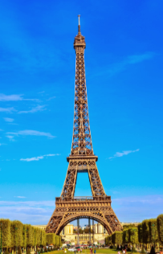 | EIFFEL TOWER

Question 2 | 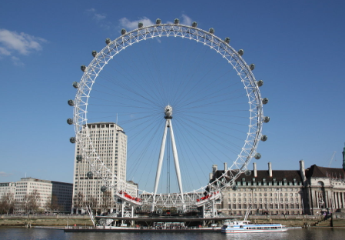 | LONDON EYE

Question 3 | 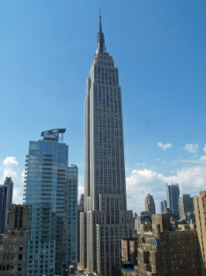 | EMPIRE STATE BUILDING

Question 4 | 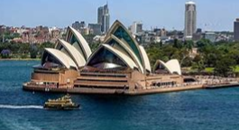 | SYDNEY OPERA HOUSE

Question 5 | 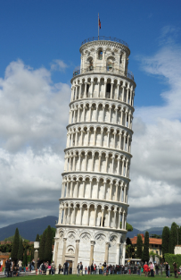 | LEANING TOWER OF PISA

Question 6 | 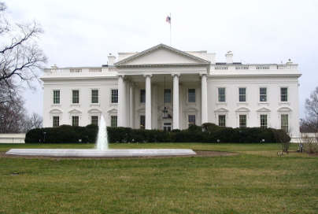 | THE WHITE HOUSE

Question 7 | 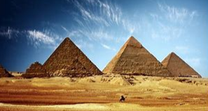 | THE GIZA PYRAMIDS

Question 8 | 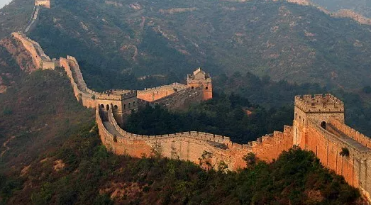 | THE GREAT WALL OF CHINA

Question 9 | 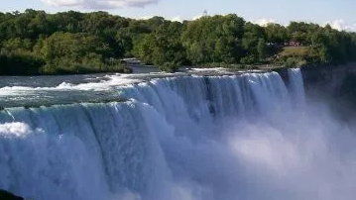 | NIAGARA FALLS

Question 10 | 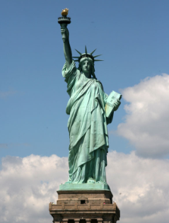 | THE STATUE OF LIBERTY

