'What Do You Need?'
Can you sort out the four clues that help and the four clues that do not help in finding the number I am thinking of?
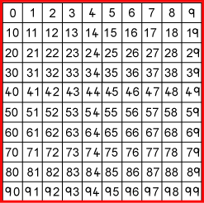
Four of the clues below are true but do nothing to help in finding the number.
Four of the clues are necessary for finding it.
Here are eight clues to use:
- The number is greater than 9
- The number is not a multiple of 10
- The number is a multiple of 7
- The number is odd.
- The number is not a multiple of 11
- The number is less than 200
- Its ones digit is larger than its tens digit.
- Its tens digit is odd.
What is the number?

