READING CUBE  Poetry | 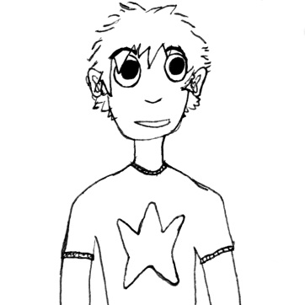 | Read poems  by 6 different poets!  On each face write the title of your 6 favourite poems and the poet - you could also add a small illustration.  Make into a cube and  add to the Reading Wall.

Your name:

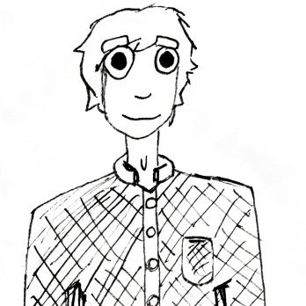 | Poetry | 