GUESS THE ITEMS THAT YOU WOULD FIND IN A SCHOOL ANSWERS
Question 1 |  | PENCIL

Question 2 |  | SCISSORS

Question 3 | 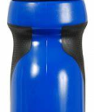 | WATER BOTTLE

Question 4 | 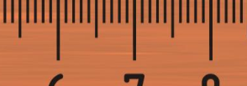 | RULER

Question 5 | 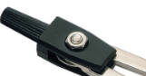 | COMPASS

Question 6 |  | CLOCK

Question 7 | 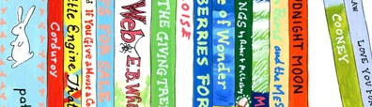 | READING BOOKS

Question 8 | 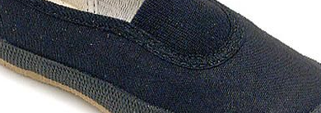 | PE DAP

Question 9 |  | CHILDREN’S BIBLE

Question 10 | 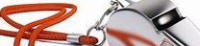 | WHISTLE

