GUESS THE CAPITAL CITY ANSWERS
Question 1 | 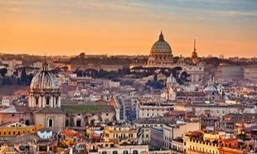 | THE CAPITAL CITY OF ITALY IS…..  ROME

Question 2 | 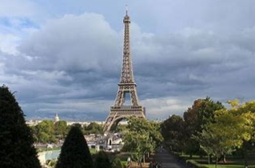 | THE CAPITAL CITY OF FRANCE IS…..  PARIS

Question 3 | 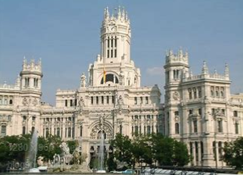 | THE CAPITAL CITY OF SPAIN IS…..  MADRID

Question 4 | 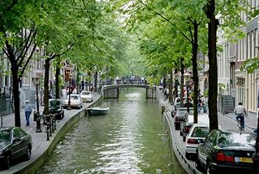 | THE CAPITAL CITY OF HOLLAND IS…..  AMSTERDAM

Question 5 | 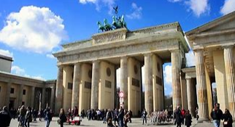 | THE CAPITAL CITY OF GERMANY IS…..  BERLIN

Question 6 | 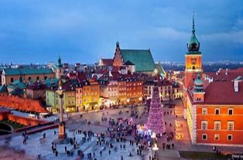 | THE CAPITAL CITY OF POLAND IS…..  WARSAW

Question 7 | 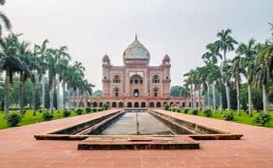 | THE CAPITAL CITY OF INDIA IS…..  NEW DELHI

Question 8 | 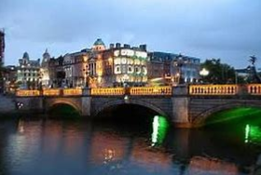 | THE CAPITAL CITY OF IRELAND IS…..  DUBLIN

Question 9 | 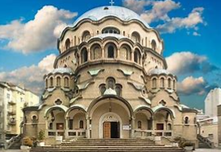 | THE CAPITAL CITY OF BULGARIA IS…..  SOFIA

Question 10 | 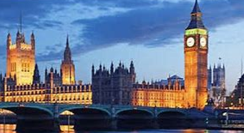 | THE CAPITAL CITY OF ENGLAND IS…..  LONDON

