READING CUBE  Non-Fiction  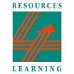 | 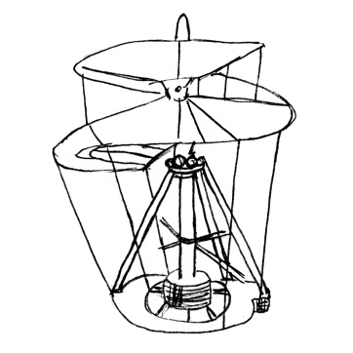 | Read 6 Information books!  On each face write the title and the author of each of the books - you could also add a small illustration.  Make into a cube and  add to the Reading Wall.
 |  |  | 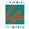

Your name:

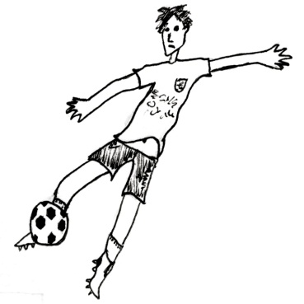 | Information  Books | 