GUESS THE PERSON FROM HISTORY
Question 1 | 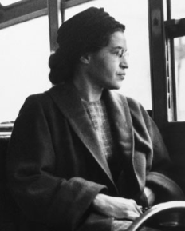 | Clue: Refused to give up her seat.  ROSA PARKS

Question 2 | 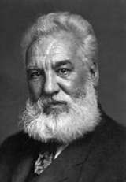 | Clue: Invented something  ALEXANDER BELL

Question 3 | 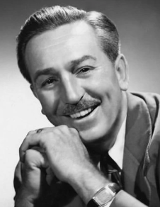 | Clue: Zipadeedoodah  WALT DISNEY

Question 4 | 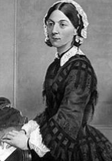 | Clue: Nurse  FLORENCE NIGHTINGALE

Question 5 | 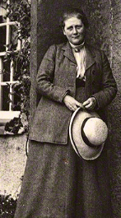 | Clue: Author  BEATRIX POTTER

Question 6 | 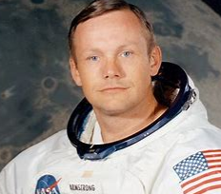 | Clue: This is one small step for a man, one giant leap for mankind  NEIL ARMSTRONG

Question 7 | 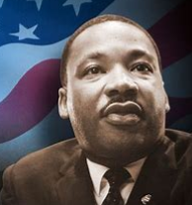 | Clue: I have a dream  MARTIN LUTHER KING JR

Question 8 | 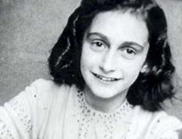 | Clue: Diary  ANNE FRANK

Question 9 | 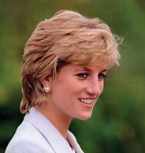 | Clue: Princess  PRINCESS DIANA

Question 10 | 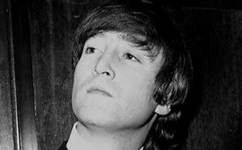 | Clue: Imagine  JOHN LENNON

