

**Year 6 Creation**

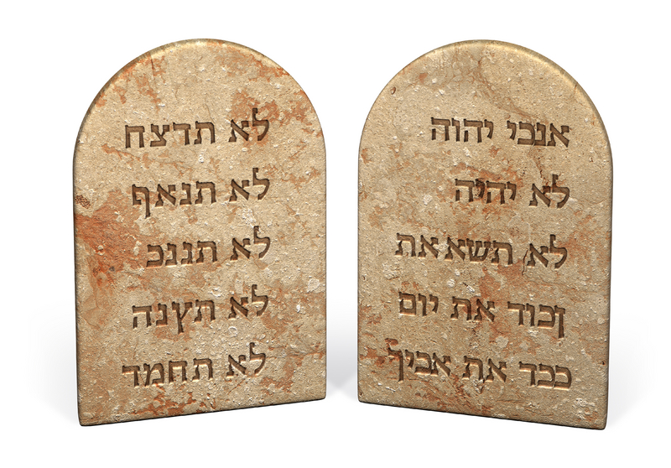

**Possible Outcomes for Pupils**

**Please Note since this is the first module in Year 6 you should scaffold the more difficult tasks for them even for those pupils working at greater depth.**

**Working towards age related outcomes**

* Make links between the story of Moses and our belief that God is with us and guides us AT1
* State some simple reasons why the Jewish people let Moses down AT1
* Make Links to show how our belief in the commandments should affect our behaviour and actions towards each other and creation AT2
* Compare their own and other people’s ideas about why some people lie or steal AT2
* Give their own views on Christians should not lie. AT3

**Age related outcomes**

* Describe and show understanding some relevant experiences of Moses relating this to some beliefs in the Christian Church. AT1 *(For example the story of the burning bush leads Moses and us to a belief in one God who walks with us in our lives)*
* Show understanding of how for people in the church their actions are informed by their belief in the commandments AT1
* Engage with and respond to the question why do some people not keep some specific commandments? AT2
* Discuss ‘The Commandments are still relevant today’ AT3 Or keeping the letter of commandments can actually be a bad thing. (For example they could refer to Keep Holy the Sabbath and look at the passage about Sabbath in Mathew Ch12- you would need to explain this)

**Working at Greater Depth**

* Identify specific people in scripture and explain how their experiences informed their belief in God. AT1i *(note for this level they would need to identify more than one person so either they would be drawing on previous or you could identify stories from scripture for them and ask them to select pieces that they consider relevant))*
* Identify people in today’s society whose actions are influenced by their understanding of the Ten Commandments.AT2
* Discuss the question ‘Love is more important than the commandments’ AT3 (please note this is a very complex question if you had some pupils you wanted to attempt you must scaffold for them. A possible framework is attached.AT3

**Prior Learning**

If pupils have worked on the Abraham story in previous years remind them of that story and that one of the central points was trust in God. (See year 4) This theme is echoed in the Moses story. You also need to remind them of the different types of books in the Bible. This story is made up of different strands which are woven together.

**Notes:**

*“God is revealed to Israel by ‘words and deeds’ which are closely connected God reveals himself to Moses as* ***‘I am who I am’*** *(Exodus 3:14). The providential action of God in delivering his people from slavery and the story of the giving of the law and the making of a covenant at Sinai are the focus of the Book of Exodus. Moses is mediator for the people and the trusted servant of God (Numbers 12:7). The covenant between God and the people is summarised in the words:* ***‘I will be your God, and you shall be my people.’*** *(Leviticus 26:12). Israel is to live totally and exclusively for God”*  **‘The Gift of Scripture’** [1]

To this day the Jewish people celebrate their freedom from slavery. The commandments are given to help them live as God’s people in their everyday lives. For us as Christians the Ten Commandments, (or Decalogue,) is still really important. The Catechism of the Catholic Church says: The commandments are a path to life.

**Possible Tasks to help you fulfil outcomes:**

**Engage:**

Watch the first part of the film Prince of Egypt (or similar) up to the Burning Bush. You will need to explain that the Israelites had been captured and many removed from their own land to work as slaves in Egypt. **The details of the Moses story are told to remind us of certain truths about God and our relationship with God. Not everything that happens in the story is necessarily literally true but the meaning behind the story is.**

* What kind of hardship did the Israelites face in Egypt? What do they hope for?
* As Moses grows up in Egypt what kind of person is he? What does he do? (T*he point here is that Moses isn’t your typical hero, he is someone who is used to the good things of life then in a fit of anger kills someone-God can work through anyone no matter what our previous lives were like)*
* In groups ask the children to re-enact the scene with the burning bush and freeze frame asking them to talk about what would have been going through their mind.

**Explore and Express**

Look at the words used to describe Moses and the burning bush.

1. Why does Moses ask who are you*? (Moses grew up in Egypt a land of many gods. He is really asking which god are you?)*
2. What does God say in reply? *Why does this answer surprise Moses? ( He realises firstly that he really is Jewish and secondly this isn’t the kind of answer he is expecting. God is saying he is the one God)*
3. What does God want? *(God responds to peoples’ prayers but not in the way you would expect. God works through others. He is asking Moses to be the one that He can work through)*
4. Are you surprised God asks Moses to help? *(Remember the kind of person Moses was?)*
5. Why doesn’t Moses want to go? *(Moses doesn’t feel strong enough or good enough and he is sacred like Abraham before him he will have to give up lots of things to answer God’s call)*
6. What does God promise? *(To be with him always)*
7. What lessons do you think this part of the story holds for us?
8. Do you believe that God is with us? Give reasons for your answer.

In relation to the learning outcomes it isn’t really necessary to spend time on the plagues etc. These aspects of the story are however important in their own ways. For now probably better to summarise. Moses does eventually free his people and they escape through the Red Sea into the desert. *(Note the story stresses that God is with them)* However when they get there they complain constantly. Life is too difficult there is no proper food, no proper water we are not sure where we are going etc. They say they would rather be slaves in Egypt. Can the children think of any situations in today’s world where people have been freed and complain?

It is worth exploring this by selecting passages from the Story. Try Exodus ch16 1-6 and Exodus 17 1-7

1. Why did they complain? *(Life was harder than they thought etc)*
2. How did God respond? (water/manna showed his concern)
3. Do we always trust in God?
4. What do we complain about?
5. Why can it be difficult to follow God?

**The Ten Commandments**

**Note:** The Ten Commandments of Moses are about living in the way God wants and treating others properly. They are not just rules and regulations. The Ten Commandments can be interpreted in different ways. In other words, their meaning is not always that simple, and it is worth discussing and thinking about them clearly. If you remember that they summarise our relationship with God and each other the you can see them in a wider context. For example: Do not Kill. You can kill by the things you don’t do as well as things you do. Letting someone starve, not giving them medical help, taking all hope away from them etc. Jesus criticised those who had a narrow interpretation of the commandments. (see Mt 12) They can be written in different ways depending on translation Catholics and Anglicans number them in different ways to make 10. (Make sure they understand all the language.)

* Create a piece of Art Work/Collage/Poem called Living in God’s Way
* Write a short play about breaking one of the commandments that could be acted out as part of an assembly or to other classes.
* Write a short story related to one of the commandments that could be read to younger pupils. .

**The Ten Commandments**

1. Read carefully the Ten Commandments on the Sheet. Which ones are directly about us and God?
2. Look at the pictures below. Which commandment do you think they refer to? What are they worshipping?

**What is peer pressure?**

Peer pressure is feeling like you have to do something just because all your friends are doing it. There's a lot of pressure to fit in, wear the same clothes as everyone else and do what they're doing



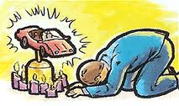

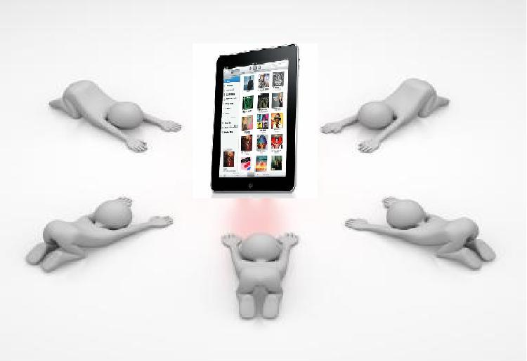

1. What kind of things might we put before God?
2. One Commandment says you must not kill. Can you kill someone by not doing something? Can we kill or steal from the planet?
3. The Sabbath for the Jewish people is Saturday because it is the last day of the week, for Christians it is Sunday because that’s the day we celebrate the resurrection of Jesus. To keep it Holy means to keep it as a day where we try especially hard to do what God wants. Design a poster showing the different ways we can keep the Sabbath Holy. Before you design this poster read Mathew’s Gospel Chapter 25 verses 31-46. Think about what this tells us about doing what God wants.
4. Rewrite the Ten Commandments but make each of them begin you must instead of you must not. This is not easy. Think carefully about what each of them means. For example number one could become always put God first.
5. Add an eleventh commandment that you think is really important for today.

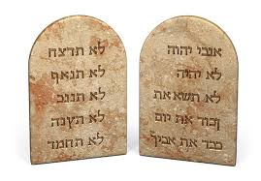

**The Ten Commandments**

**I am the LORD your God:**

**1. You shall not have strange Gods before me. That is do not worship false gods.**

**2. You shall not take the name of the LORD your God in vain.**

**3. Remember to keep holy the Lord’s Day. (Sabbath)**

**4. Honour your father and your mother.**

**5. You shall not kill.**

**6. You shall not commit adultery.**

**7. You shall not steal.**

**8. You shall not bear false witness against your neighbour.**

**9. You shall not covet your neighbour’s wife.**

**10. You shall not covet your neighbour’s goods.**

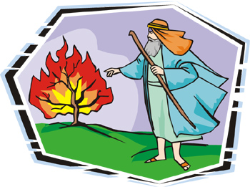**The Burning Bush**

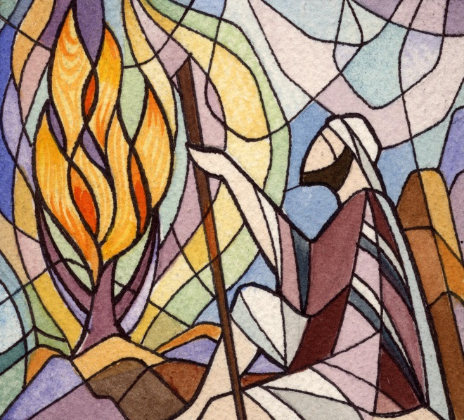**God**: Moses....Moses....Moses....Moses  
**Moses**: Here I am.  
God: Take the sandals from your feet...for the place on which you stand is holy ground.  
**Moses:** Who are you?  
**God:** I AM that I AM.  
**Moses:** I don't understand...  
**God:** I am the God of your ancestors: Abraham, Isaac, and Jacob  
**Moses:** What do you want with me?  
**God:** I have seen the oppression of My people in Egypt, and have heard their cry. So I have come down to deliver them out of slavery, and bring them to a good land. A land flowing with milk and honey. And so unto Pharoah, I shall send you.  
**Moses:** Me? Who am I to lead these people? They'll never believe me, they won't even listen.  
**God:** I shall teach you what to say...  
**Moses:** But I was their enemy. I was the Prince of Egypt, the son of the man who slaughtered their children. You've, you've chosen the wrong messenger. How, how can I even speak to these people?  
**God:** Who made man's mouth?! Who made the deaf, the mute, the seeing, or the blind?! Did not I?! Now go!   
Oh, Moses. I shall be with you when you go to the King of Egypt, but Pharoah will not listen. So I will stretch out My hand, and smite Egypt with all My wonders. Take the staff in your hand Moses, with it, you shall do My wonders. I shall be with you,

**Framework for the question Love is more important than Law. It assumes they have done a lot of other work before they get to this question.**

**(Please note this is only one way to do this)**

* First paragraph. Where do the Ten Commandments come from? What are they (do not list them but say what they were designed to do).
* Second paragraph. How can the commandments be misunderstood? How can they be misunderstood? (For example if you take the commandment Do Not Steal most people think it is about stealing objects from others but can you steal someone’s good name by gossiping, can you steal someone’s future if you don’t provide them with enough food to live?) How do you think most people see the commandments? Refer to Jesus and how he got into trouble for appearing to break one of the commandments (MT:12)
* Third Paragraph. What Commandments did Jesus give? Look at Mt22: 37-39 and John 13:34 Do you think these are harder or easier to keep? Look at what Saint Paul had to say about love. Cor13: 4-7. What would happen if everyone tried to live in this way/
* Final paragraph. Sum up your own views on the question Love is more important than law giving reasons for your answer.

1. Find this book on <http://www.cbcew.org.uk/> and follow link to publications.