READING CUBE  Fiction | 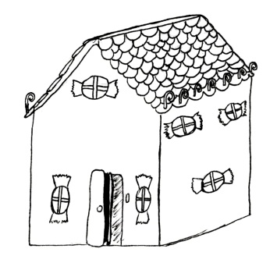 | Read 6 different  fiction genres!  On each face write the title of each book and the author – you could also add a small illustration.  Make into a cube and  add to the Reading Wall. | Adventure story
 |  |  | 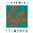
Sci – Fi story  Your name: | Historical story | Picture Book | Traditional tale
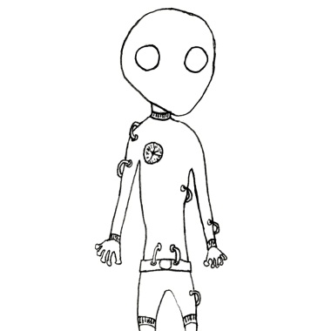 | Fiction  Genre | 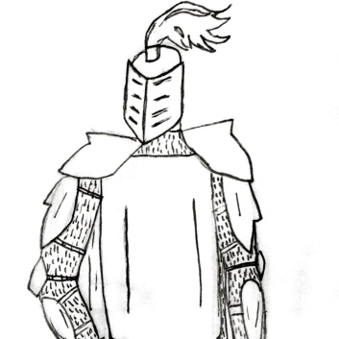 | Fantasy Story

