GUESS THE BOOK CHARACTER ANSWERS
Question 1 | 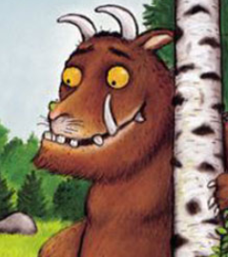 | THE GRUFFALO

Question 2 | 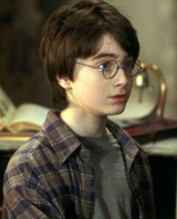 | HARRY POTTER

Question 3 | 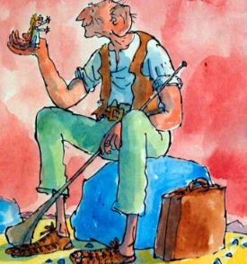 | THE BFG

Question 4 | 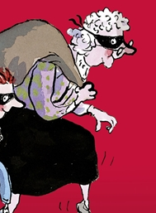 | GANGSTA GRANNY

Question 5 | 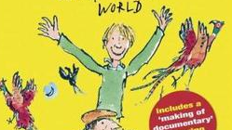 | DANNY

Question 6 | 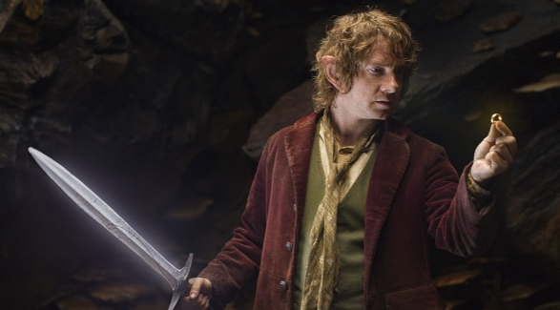 | BILBO BAGGINS

Question 7 | 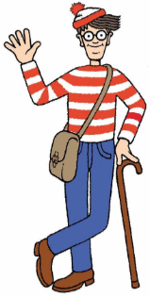 | WHERE’S WALLY

Question 8 | 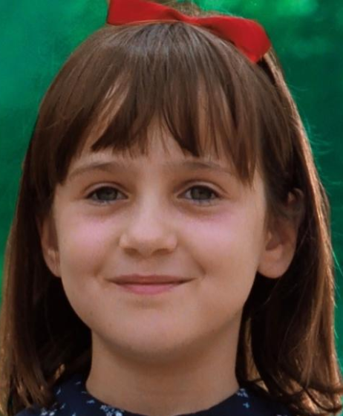 | MATILDA

Question 9 | 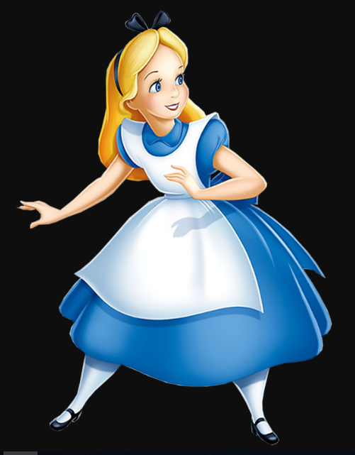 | ALICE IN WONDERLAND

Question 10 | 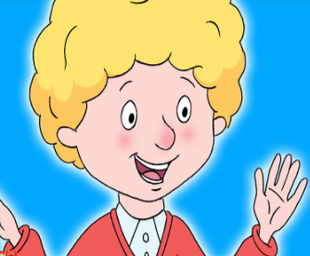 | PERFECT PETER

