BUMPER EASTER QUIZ
ROUND ONE – GUESS THE GAME
Question 1 | 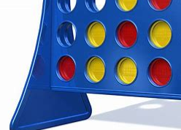

Question 2

Question 3

Question 4

Question 5 | 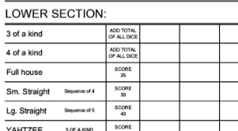

Question 6 | 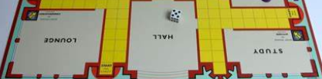

Question 7 | 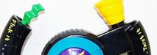

Question 8

Question 9

Question 10

Question 11

Question 12

Question 13

Question 14 | 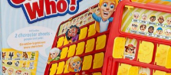

Question 15

Question 16 | 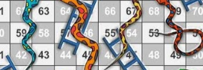

Question 17

Question 18

Question 19 | 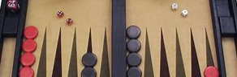

Question 20

ROUND TWO – GUESS THE MUSIC STAR
Question 21

Question 22

Question 23

Question 24

Question 25

Question 26

Question 27

Question 28

Question 29

Question 30

Question 31

Question 32 | 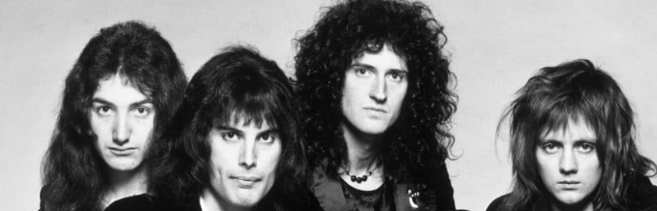

Question 33 | 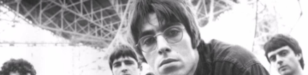

Question 34

Question 35

Question 36

Question 37

Question 38

Question 39

Question 40

ROUND THREE – GUESS THE MOVIE

Question 41

Question 42

Question 43

Question 44

Question 45

Question 46 | 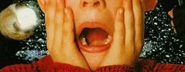

Question 47

Question 48

Question 49

Question 50

Question 51

Question 52 | 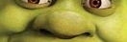

Question 53

Question 54

Question 55

Question 56 | 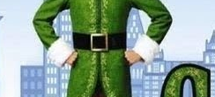

Question 57

Question 58

Question 59

Question 60 | 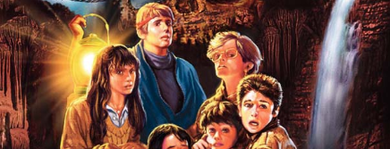

ROUND FOUR – GUESS THE SPORTS STAR

Question 61

Question 62

Question 63 | 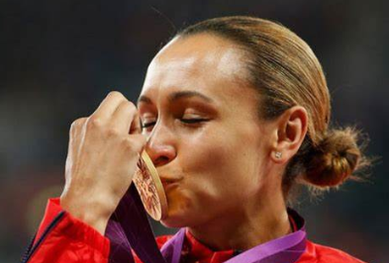

Question 64

Question 65

Question 66

Question 67

Question 68

Question 69

Question 70

Question 71

Question 72

Question 73

Question 74

Question 75

Question 76

Question 77

Question 78

Question 79

Question 80

ROUND FIVE – GUESS THE TV SHOW
Question 81

Question 82 | 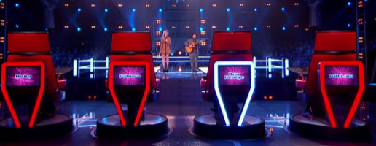

Question 83

Question 84

Question 85

Question 86 | 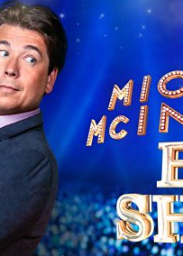

Question 87

Question 88

Question 89

Question 90

Question 91 | 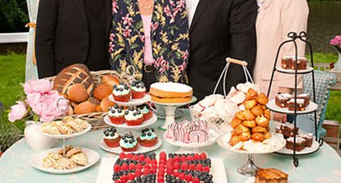

Question 92

Question 93

Question 94

Question 95 | 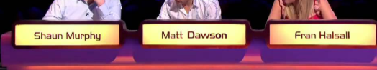

Question 96

Question 97 | 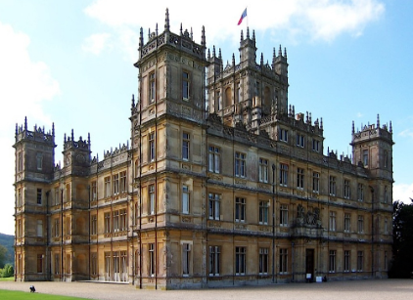

Question 98

Question 99

Question 100 | 