ANSWERS TO GUESS THE PLACES
Have a go at seeing how many places you can spot around Taunton?
Question 1 | 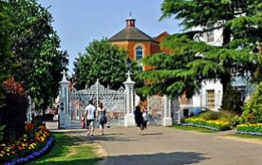 | This is…….  Vivary Park

Question 2 | 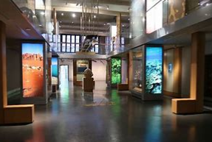 | This is…….  Taunton Museum

Question 3 | 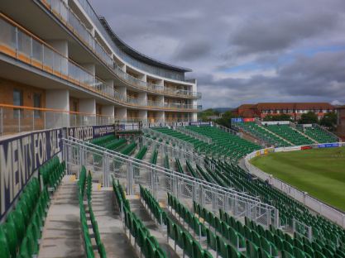 | This is…….  Somerset County Cricket Ground

Question 4 | 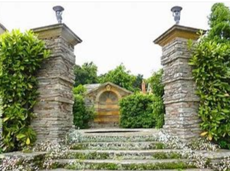 | This is…….  Hestercombe Gardens

Question 5 | 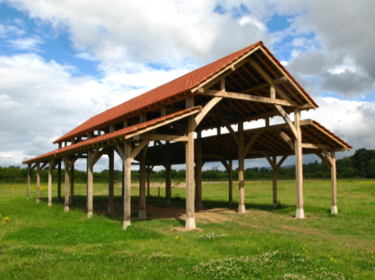 | This is…….  Longrun Meadow

Question 6 | 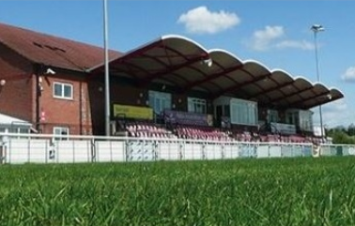 | This is…….  Taunton Rugby Club

Question 7 | 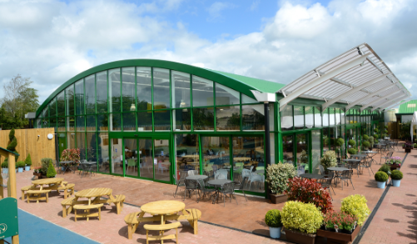 | This is…….  Monkton Elm Garden Centre

Question 8 | 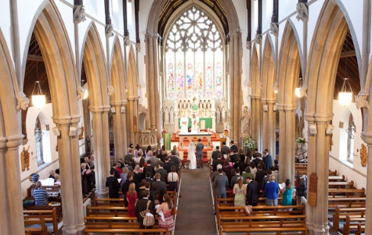 | This is…….  St George’s Catholic Church

Question 9 | 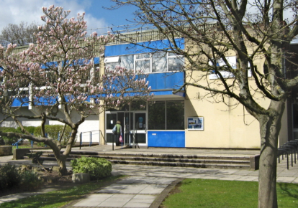 | This is…….  Taunton Swimming Pool

Question 10 |  | This is…….  Our wonderful school!

