GUESS THE TV CHARACTER
Question 1 | 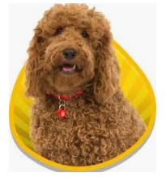 | WAFFLE THE WONDER DOG

Question 2 | 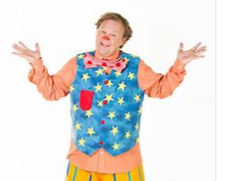 | MR TUMBLE

Question 3 |  | TOPSY AND TIM

Question 4 | 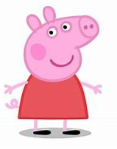 | PEPPA PIG

Question 5 | 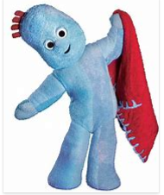 | IGGLE PIGGLE

Question 6 | 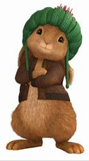 | BENJAMIN BUNNY

Question 7 | 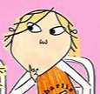 | CHARLIE

Question 8 | 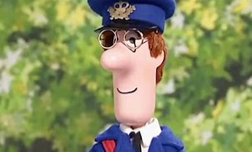 | POSTMAN PAT

Question 9 | 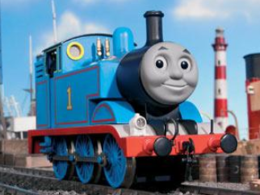 | THOMAS THE TANK ENGINE

Question 10 | 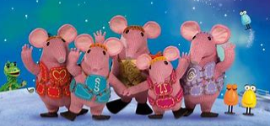 | THE CLANGERS

