GUESS THE CAPITAL CITY ANSWERS
Question 1 | 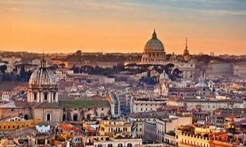 | THE CAPITAL CITY OF ITALY IS…..

Question 2 | 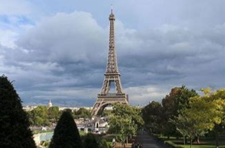 | THE CAPITAL CITY OF FRANCE IS…..

Question 3 | 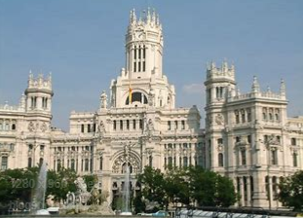 | THE CAPITAL CITY OF SPAIN IS…..

Question 4 | 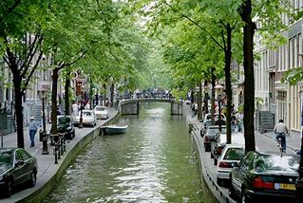 | THE CAPITAL CITY OF HOLLAND IS…..

Question 5 | 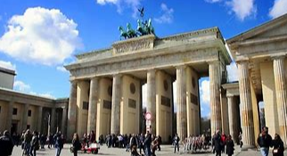 | THE CAPITAL CITY OF GERMANY IS…..

Question 6 | 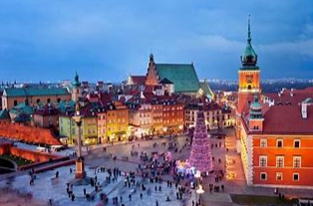 | THE CAPITAL CITY OF POLAND IS…..

Question 7 | 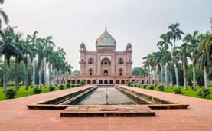 | THE CAPITAL CITY OF INDIA IS…..

Question 8 | 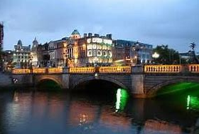 | THE CAPITAL CITY OF IRELAND IS…..

Question 9 | 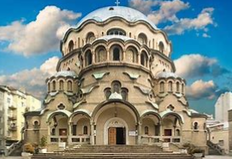 | THE CAPITAL CITY OF BULGARIA IS…..

Question 10 | 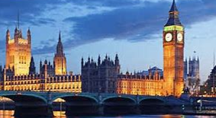 | THE CAPITAL CITY OF ENGLAND IS…..

