GUESS THE PERSON FROM HISTORY
Question 1 | 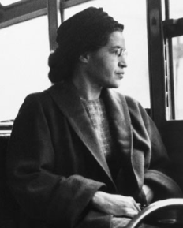 | Clue: Refused to give up her seat.

Question 2 | 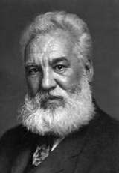 | Clue: Invented something

Question 3 | 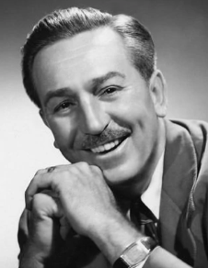 | Clue: Zipadeedoodah

Question 4 | 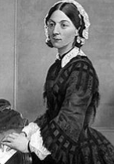 | Clue: Nurse

Question 5 | 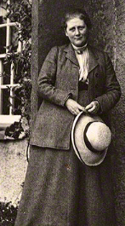 | Clue: Author

Question 6 | 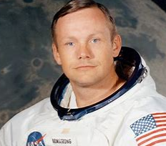 | Clue: This is one small step for a man, one giant leap for mankind

Question 7 | 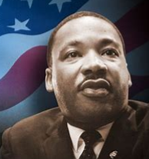 | Clue: I have a dream

Question 8 | 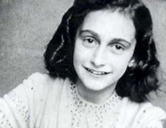 | Clue: Diary

Question 9 | 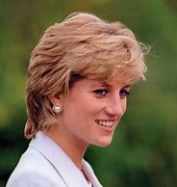 | Clue: Princess

Question 10 | 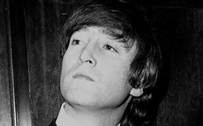 | Clue: Imagine

