GUESS THE ITEMS THAT YOU WOULD FIND IN A SCHOOL
Question 1

Question 2

Question 3 | 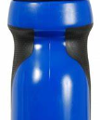

Question 4

Question 5

Question 6

Question 7

Question 8 | 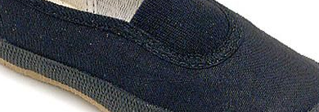

Question 9

Question 10

