

**Year 4 Creation**

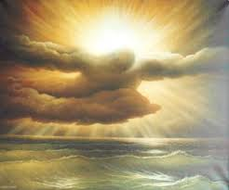





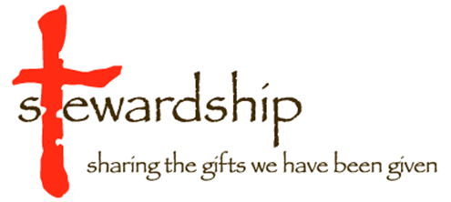

**Possible outcomes:**

**Working towards age related outcomes**

* Describe what a steward does and be able to make simple statements about what being a steward of creation is. AT1
* Know at least 3 quotes from either current church teaching or scripture about taking care of creationAT1
* Ask and respond to questions about putting these words into action. AT2
* Be able to ask questions how people take care of the world today AT2
* Retell part of the story of Abraham AT1
* Ask and respond to questions about Abraham’s actions AT2

**Age Related Outcomes**

* Explain what a Steward of creation is. AT1
* Make links between what scripture says about creation and the responsibility of believers to show care and respect for creation. AT1
* Explain the ideas behind Laudato Si. AT1
* Compare their own and other people’s ideas about questions that can be difficult to answer such as why do some people have more than others, why do some people not care for creation AT2
* Describe the story of the call of Abraham, and/or Abraham and Isaac explaining how this shows Abraham’s trust in God AT1
* Answer the question Do (I, my school, my parish) put the words of Pope Francis into Action? AT3

**Working at greater depth**

* Answer the question ‘Do Christians have to be Stewards of Creation’. They should use more than one source in answering the question and use the evidence in a logical way. AT3
* Answer the question ‘Was Abraham right to trust God’. What does this mean for Christians today? They must give reasons for their answer and their answers must reflect the meaning of the story. For example it would be completely wrong to say the story means Christians must be prepared to kill their first born if God asks!!!!

**Notes for teachers**

This work has been organised to try to avoid too much repetition so it begins with the concept of stewardship. Links this to aspects of scripture then looks at Abraham as an example of someone who trusted in God

As a teacher you may want to look at Pope Francis’ latest work ‘Laudato Si’ which is all about caring for creation most of this is too complicated for primary however I have included some images and quotes from the document on the powerpoint. As an extension project pupils could take a quote and explain what they think it means and or research what Laudato Si is.

|  |
| --- |
| As Catholics we believe that **everyone** is created in the image of God. What does it mean to be created in God’s image? Not a physical thing but we can be like God in the way we love and care for each other and our world. We have been given the responsibility of looking after creation. We live in the world and we need the world to survive so looking after creation is in a way looking after ourselves. As 'co-creators' then, our acts should reflect God's own love for creation.  *“A way of life that disregards and damages God's creation, forces the poor into greater poverty, and threatens the right of future generations to a healthy environment and to their fair share of the*  *earth's wealth and resources, is contrary to the vision of the Gospel.”* ***‘The Call of Creation’*** This document is well worth reading and you can find it on the Bishops’ Conference website.  Abraham is the recipient of God’s promises and of God’s free gifts, the man of faith who trusts that God will provide for him *(Genesis 15:6, 22:8).* The apostle Paul commends him as a model for Christian belief. He is remembered as ‘father of many nations’ *(Romans 4:18)* and is commemorated in the liturgy as ‘our father in faith’ ‘The Gift of Scripture’  The central theme of this story **is Trust in God.** Abraham leaves everything he has to go to a new place, he believes in God’s promise even when it seems really unlikely and he trusts in God so much he will place everything into God’s hands even his son. Abraham hears the word of God and lives by it. In that way he is a good steward. Because of his trust he is able to care for others and the world around him in the way that God wants. There are 3 aspects to this story that you may want to focus on:   1. Abraham is called by God and must leave everything he knows behind to follow God 2. Abraham trusts that God will give him a son even though it seems impossible 3. Abraham trusts that God will not let his son come to harm   If you have only a short time and can find the BBC Testament version use this and look at story as a whole highlighting key points. |

**Additional Tasks that may support these outcomes**:

For all the work in this topic if **you look at Cafod’s Come and See pages for the universal church you will find some excellent resources in the year 5 section.** comeandsee.cafod.org.uk (Note God Matters and Come and See do not have topics in the same order; the year 5 section of Come and See most closely matches the year 4 section of God Matters. You will also find a really good animation which summarises Laudato Si for children. <https://cafod.org.uk/Education/Primary-schools/Laudato-Si-animation> (This is also available on youtube)

**Engage**

* How do pupils care about a pet, a person an object? Bring in the object or do a brief presentation on the object. Describe how they take care of it. Why do we take care of these things? Why might others not care about it in the same way? How would they feel if someone destroyed it or hurt it?
* Being a Steward. Explore concept/ idea of stewardship for example: Football Stewards. Look at worksheet. Introduce the idea/concept of Stewards of Creation. What are the similarities and differences between being a football steward and a steward of creation*? (Pupils could work in groups outlining their thoughts, look at each other’s ideas then draw up key characteristics)*

**Explore and Express**

We are called to be Stewards of Creation. These tasks will explore what scripture teaches us about how we should respond and the teaching of the Church. A document well worth reading (from an adult perspective) is ‘The Call of Creation’ which was produced by the Bishops of England and Wales and can be found on the Bishops’ Conference website. [www.cbcew.org.uk](http://www.cbcew.org.uk)

* Pupils read and underline what they consider to be the key words of Pope Francis on the need to be Stewards of Creation (Please note although the speech is Pope Francis’ from World Youth day I have adapted it to make it easier for Year 4 pupils to understand ) *This work could be done either individually or in pairs.* Then explain what Pope Francis is saying in their own words. Make links with the actions of people. You could invite a priest or representative of the parish in to answer questions about how they are living out these words.
* Look at the words of the Canticle of the Sun by St Francis. (Note you could also explore this through the Cafod website where they have a powerpoint on this or use you tube to find similar examples). Note this is in the Year 5 section of Cafod’s come and see website. You need to log in to obtain this but it is free. Explain what Francis is saying here.
* Pupils could compare and contrast the words of Pope Francis, or scripture, or St Francis with images of the way we pollute our world.
* Ask the pupils to design posters saying **Christians** believe you should care for creation because………. Besides the texts already mentioned you could also use the texts on the sheet below.
* Pupils could write their own speech as if they were the Pope about being a good Steward of Creation referring to some of the ideas outlined in the Scripture quotes.
* Look at the story of the call of Abraham. Either watch the BBC testament video or some other resource. If you do not have a copy of this in school it is on you tube <https://www.youtube.com/watch?v=BbPJgVWPpPM> There is a powerpoint avaliable at [www.primaryresources.co.uk/re/powerpoint/Abrahams.ppt](http://www.primaryresources.co.uk/re/powerpoint/Abrahams.ppt) but you would need to adapt this. The task set on this is too simple but the questions asked would make a good starting point. If time tell other parts of the Abraham story. Note if telling the story of Abraham and Isaac you must make the point that at the time other societies believed in human sacrifice. This story is about trusting in God and about the fact that God did not want sacrifices like this.
* Ask the question what do you think the story of Abraham teaches us?

**Scripture Quotes**

**God cares about creation**

In the beginning God created the heavens and the earth... God saw all that he had made, and it was very good." (Genesis 1:1, 31)

"You made the heavens, even the highest heavens, and all their starry host, the earth and all that is on it, the seas and all that is in them. You give life to everything, and the multitudes of heaven worship you." (Nehemiah 9:6)

You (GOD) care for the land and water it; you enrich it abundantly. The streams of God are filled with water to provide the people with grain, for so you have ordained it. You drench its furrows and level its ridges; you soften it with showers and bless its crops. You crown the year with your bounty, and your carts overflow with abundance. The grasslands of the desert overflow; the hills are clothed with gladness. The meadows are covered with flocks and the valleys are mantled with grain; they shout for joy and sing." (Psalm 65:9-13)

Through him all things were made; without him nothing was made that has been made." (John 1:3)

**We must care for creation**

If you follow my statutes and keep my commandments and observe them faithfully, I will give you your rains in their season, and the land shall yield its produce, and the trees of the field shall yield their fruit." (Leviticus 26:3-4) (***We need to respect the land in order to make sure it will provide us with all we need to live)***

"You shall not pollute the land in which you live.... You shall not defile the land in which you live, in which I also dwell; (Numbers 35:33-34)

When the poor and needy seek water, and there is none, and their tongue faileth for thirst, I the LORD will hear them, I the God of Israel will not forsake them.***ISAIAH Chapter 41 verses 17 (If God wants to help we must do the same)***

***There are many other scripture passages. The teaching of Jesus as a whole insists that we must take care of each other.***

For I was hungry and you gave me something to eat, I was thirsty and you gave me something to drink Mt 25 v35

Please see the Cafod work for more tasks and quotes.

*Abraham is the recipient of God’s promises and of God’s free gifts, the man of faith who trusts that God will provide for him (Genesis 15:6, 22:8). The apostle Paul commends him as a model for Christian belief. He is remembered as ‘father of many nations’ (Romans 4:18) and is commemorated in the liturgy as ‘our father in faith’ ‘The Gift of Scripture’*

The central theme of this story **is Trust in God.** Abraham leaves everything he has to go to a new place, he believes in God’s promise even when it seems really unlikely and he trusts in God so much he will place everything into God’s hands even his son. Abraham hears the word of God and lives by it.

If you are doing Abraham then you need to select which parts of the story you will use. The story can be found in various different formats on the internet.

Suggest the following:

* ***There was a series called Testament the Bible in Animation produced on DVD there is one on Abraham which is excellent and really brings out there feelings. It is available to download from You tube.***
* Genesis 12 v1-6 The story of how Abraham calls God to follow him. Questions to pose how much trust do you need to have in someone to leave everything you have and follow God? How difficult a decision do you think this was for him? How is this similar to the choices priests and nuns make?
* The story of Abraham and Isaac. **Note in the countries around them people did believe in human sacrifice but this story makes the point that this is not what God wants what he requires is that we are always prepared to choose God first.** Abraham tells his son when he asks about sacrifice that the Lord will provide. His trust in God was total. You must emphasise here that this isn’t about God demanding sacrifice but about Abraham’s total trust in God

**Football Stewards**

**By looking at the pictures and reading the article can you say what a football steward does? What qualities do you think you would need to be a good steward? What would happen if people didn’t do as the stewards asked? How would this affect others?**

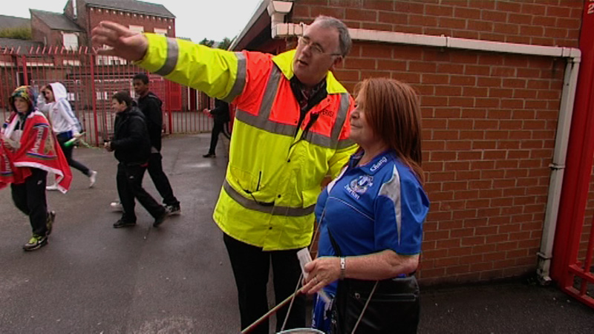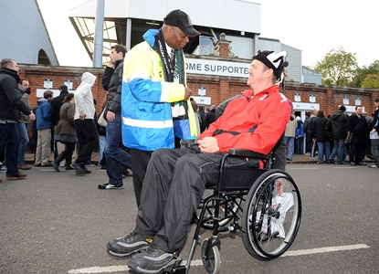

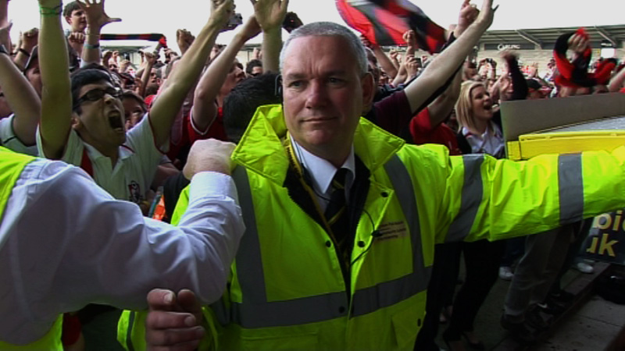

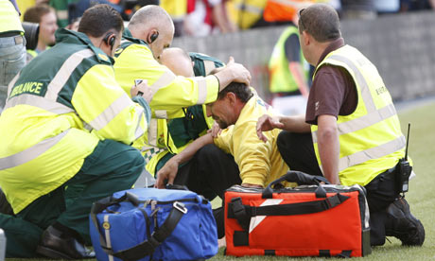

English Football Stewards have long been recognised as being amongst the best in the world. They are the most visible of club staff and in times of crisis they protect spectators and save lives. They also have a fundamental impact on the fans experience on a match day. They have to learn about: Spectator Safety, Fire Awareness, Customer Service, First Aid, Crowd Management, Disability Awareness, Conflict Management and Teamwork.

**What other kinds of Stewards can you think of? How is there role similar to football stewards?**

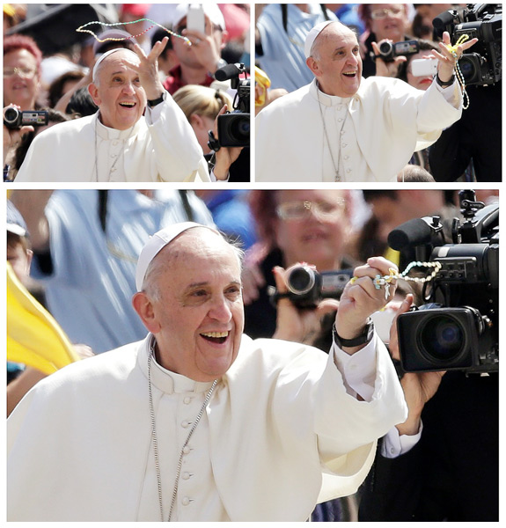**Read these words by Pope Francis.**

Pope Francis called for "**respect** and **protection** of the **entire creation** which God has entrusted to man, not so that it be exploited but rather made into a garden."

At World Youth Day in Brazil (this is an event for young people and three million young people from 175 countries gathered to listen to the Pope) he also said:

When we talk about the environment, about creation, my thoughts turn to the first pages of the Bible, the Book of Genesis, which states that God placed man and woman on earth to cultivate and care for it (cf. 2:15). And the question comes to my mind: **What does cultivating and caring for the earth mean?** Are we truly cultivating and caring for creation**? Or are we exploiting and neglecting the world?**

Once our grandparents **were very careful not to throw away any leftover food.** But we have got used to food always being there and we just waste it. We should all remember, however, **that throwing food away is like stealing from the tables of the poor, the hungry!**  **I encourage everyone to think about how we throw away and waste food** and to **think about what we can do not to waste things** but to **share with** others.

A few days ago, we read the story of the miracle of the loaves: Jesus feeds the crowd with five loaves and two fishes. And the conclusion of the piece is important: " They all ate and were satisfied. And when the leftover fragments were picked up, they filled twelve wicker baskets" (Lk 9:17). **Jesus asks his disciples not to throw anything away: no waste!** There is this fact of twelve baskets: Why twelve? What does this mean? Twelve is the number of the tribes of Israel, which symbolically represent all people. And this tells us that when food is shared in a fair way, when no one is left out every community can meet the needs of the poorest.

**What do you think he is asking us to do? What doesn’t he like people doing?**

**What stories from Scripture does he mention?**

**What does he tell us is the message of these stories?**

***Read Carefully the poem called the Canticle of the Sun. This is by St Francis.***

Saint Francis praises God for some of the wonders of the natural world. Francis believed that everything in the natural world was a gift from God and, as such, deserved to be appreciated and valued.

***What does Francis praise the Sun for? Why do think he says this is like God?***

***What does he praise water for?***

***What does he praise the earth for?***

***At the end of his poem he gives us tasks. What are they?***

***When you have read the poem, study the next sheet ,which shows pictures of parts of our world and gives some information.***

***Firstly say what the pictures are telling you about our world today.***

***Secondly imagine you were Francis how would you feel about what is on the sheet?***

***Create your own poster about positive things people are doing to help the natural world. For example things like recycling or picking up litter , not using plastic carrier bags.***

***The Canticle of the Sun by St Francis***

*Most High, all-powerful, all-good Lord,  
All praise is Yours, all glory, all honour and all blessings.  
To you alone, Most High, do they belong,  
and no mortal lips are worthy to pronounce Your Name.*

*Praised be You my Lord with all Your creatures,  
especially Sir Brother Sun,  
Who is the day through whom You give us light.  
And he is beautiful and radiant with great splendour,****Of You Most High, he bears the likeness.***

*Praised be You, my Lord, through Sister Moon and the stars,  
In the heavens you have made them bright, precious and fair.*

*Praised be You, my Lord, through Brothers Wind and Air,  
And fair and stormy, all weather's moods,****by which You cherish all that You have made.***

*Praised be You my Lord through Sister Water,****So useful, humble, precious and pure.***

*Praised be You my Lord through Brother Fire,  
through whom You light the night  
and he is beautiful and playful and robust and strong.*

*Praised be You my Lord through our Sister,  
Mother Earth****who sustains and governs us,  
producing varied fruits with coloured flowers and herbs.***

*Praise and bless my Lord and give Him thanks,****And serve Him*** *with great humility.*

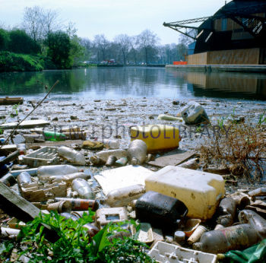***A river in London***

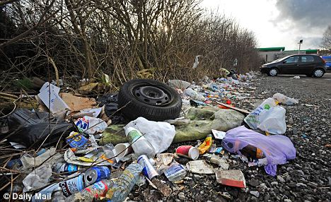

***On the banks of a river near Preston***

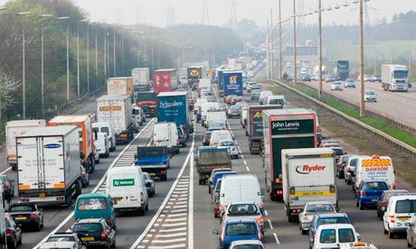***Air pollution in Britain***