GUESS THE FAMOUS PERSON FROM HISTORY - ANSWERS
Question 1 | 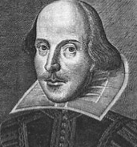 | WILLIAM SHAKESPEARE

Question 2 | 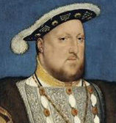 | HENRY VIII

Question 3 | 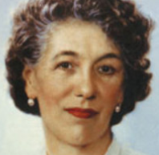 | ENID BLYTON

Question 4 | 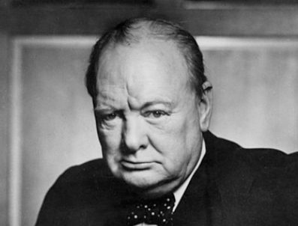 | WINSTON CHURCHILL

Question 5 | 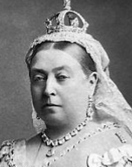 | QUEEN VICTORIA

Question 6 | 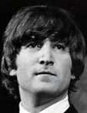 | JOHN LENNON

Question 7 | 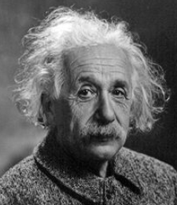 | ALBERT EINSTEIN

Question 8 | 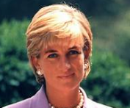 | PRINCESS DIANA

Question 9 | 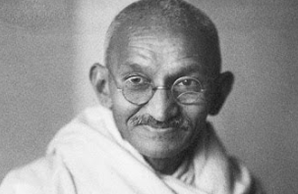 | MAHATMA GANDHI

Question 10 | 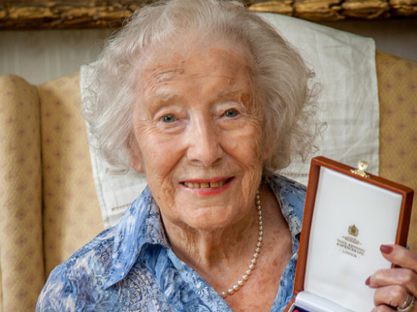 | DAME VERA LYNN

